Database Structure
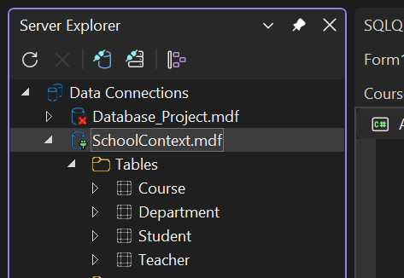
StudentForm.Design
Pre-Filled Data
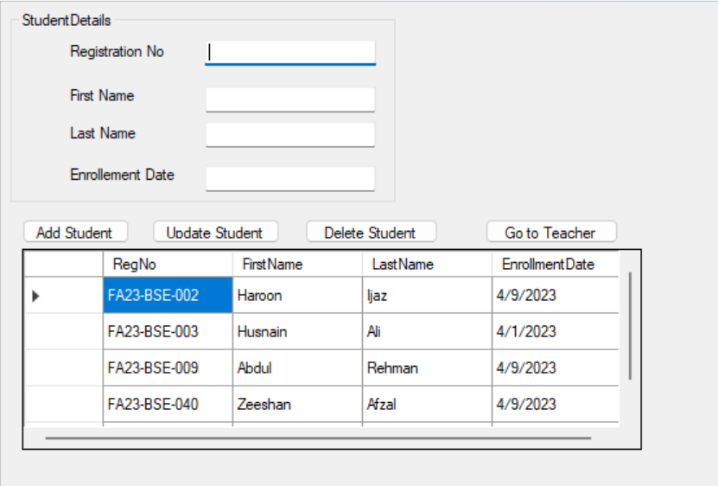
Add New Data (Bilal Saeed)
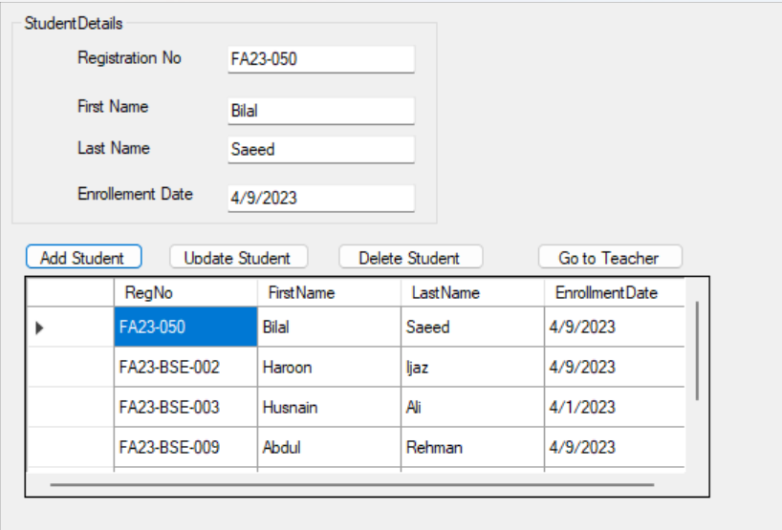
Update Data (Zeeshan Afzal to Zeeshan Khan)
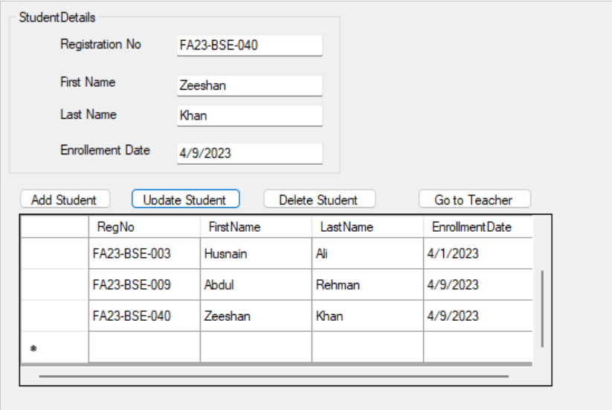
Delete Student (Husnain Ali)
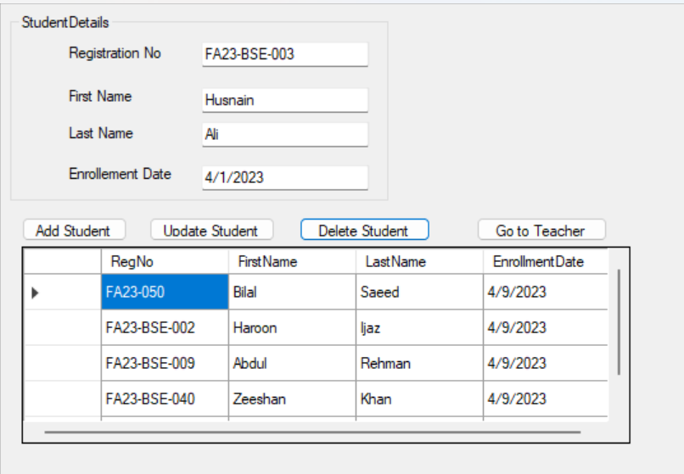
Go to Teacher Button
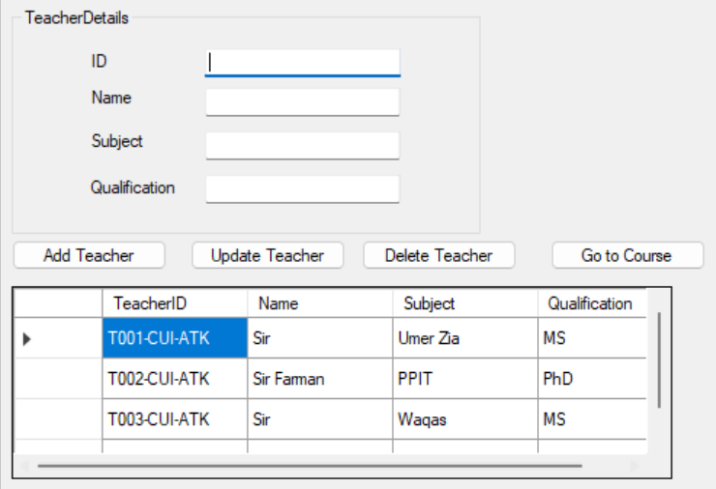
TeacherForm.Design
Pre-Filled Data

Add New Teacher (Sir Abbas)
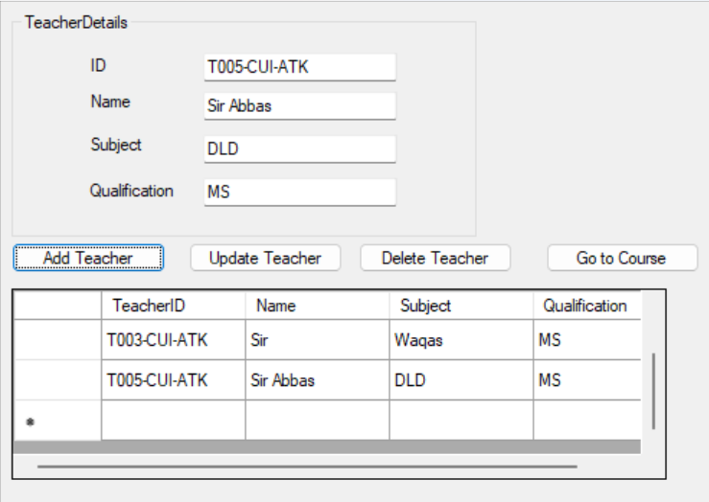
Update Subject (with T003-CUI-ATK to AP)
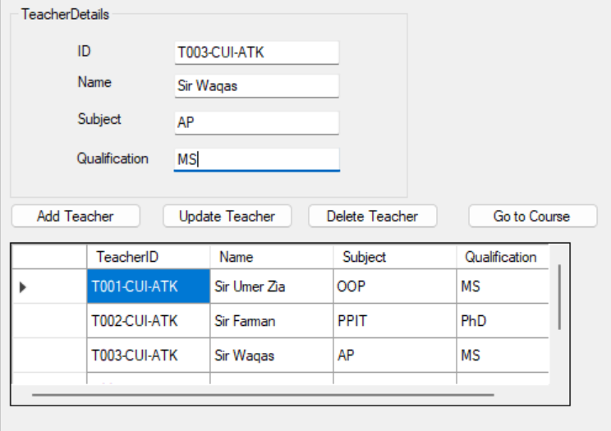
Delete Teacher (With id T005-CUI-ATK)
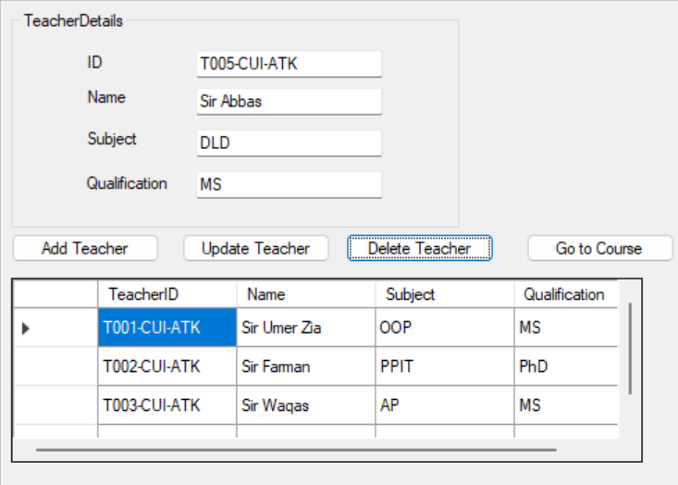
Go to Course
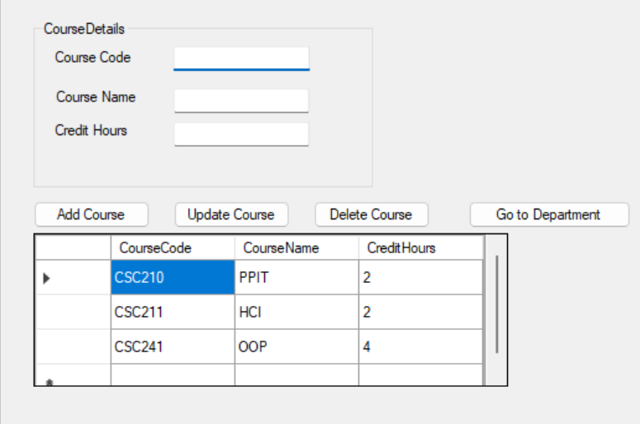
Note: Same logic and Form Style for Course and Department

